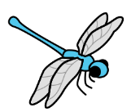
Science:
Our topic this term is Animals including Humans. This half term we will be focussing on the animal classification groups, mammals, fish, birds, amphibians, reptiles and humans. We will be looking at the features of each group. Y2s will be building upon their knowledge of these groups from the Summer term and thinking about what each of these groups need to survive.
PE: This half term our unit of learning is Hit Catch Run. We will be developing our hitting skills with a variety of bats. Practicing feeding/bowling skills and hitting and running to score points in games.
Dragonflies
Autumn 1

Art: This half term our art work will focus on the work of Guiseppe Arcimboldo. He is famous for using unusual objects like fruit and vegetables to create portraits. We will learn about who Guiseppe Arcimboldo was, learn about his life and then focus on using different techniques to create portraits in the style of Arcimboldo.

Maths: In our maths lessons we will be focusing on numbers this half term. We will be starting with a place value (within 20) unit. We will be focusing on the composition of these numbers, counting forwards and backwards, finding one more, one less and putting these numbers on a number line. We will then be moving onto an addition and subtraction unit. Within this unit we will be practicing our addition and subtraction skills, doubles, near doubles, number bonds to 10 and 20 and fact families.

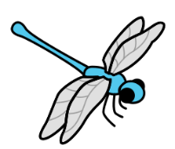
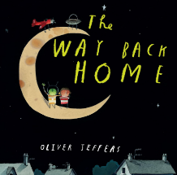
Music:
We will explore South African music through listening, singing and playing. While developing our understanding of pulse, rhythm and pitch while improvising, composing and performing our own musical ideas.
R.E: Christianity: Is it possible to be kind to everyone all of the time? We will be reflecting on what kindness is, when it might be difficult to show kindness and times where Jesus talks about kindness in the Bible.

PSHE: Our unit this half term is: Being me in my world: Rights and responsibilities in class and school. In this unit we discuss our hopes and fears for the year ahead – we talk about feeling worried and recognising when we should ask for help and who to ask. We talk about rights and responsibilities; how to work collaboratively, how to listen to each other and how to make our classroom a safe and fair place. We also talk about choices and the consequences of making different choices.

Computing: This half term our unit is IT around us. We will be developing their understanding of what information technology (IT) is and will begin to identify examples. We will discuss where we have seen IT in school and beyond. We will also learn about the importance of using IT responsibly.

English: Our English lessons this half term will be based on the story The Way Back Home by Oliver Jeffers. We will slowly share the story over the first few weeks, thinking about different features of writing as we do. We will then spend some time writing our own versions of the story.
As the setting of the story is Space we
will also spend some time learning
about what is in space.

Geography:
Our enquiry question is: How does Kampong Ayer compare with where I live? We will be learning all about Kampong Ayer, we will locate it on a map of the world. We will learn about the local geography of Brunei, the climate, the buildings and how people travel around. We will compare this to where we live in Norfolk, discussing similarities and differences.

